Instruction for install [GroIMP](http://ufgb966.forst.uni-goettingen.de/GroIMP/)

Install and run GroIMP step by step:

# functional-structural-apple-model

Download the AppleMode file from github and save in local disk.

## Install java 1.8

Download and install java 1.8 from the oracle website:

[https://www.oracle.com/java/technologies/downloads/#jre8-windows](https://www.oracle.com/java/technologies/downloads/" \l "jre8-windows)

##Download and install GroIMP 1.6 or later version.

Download GroIMP 1.6 from <http://ufgb966.forst.uni-goettingen.de/GroIMP/> and chose GroIMP-1.6-win64.exe as highlighted.

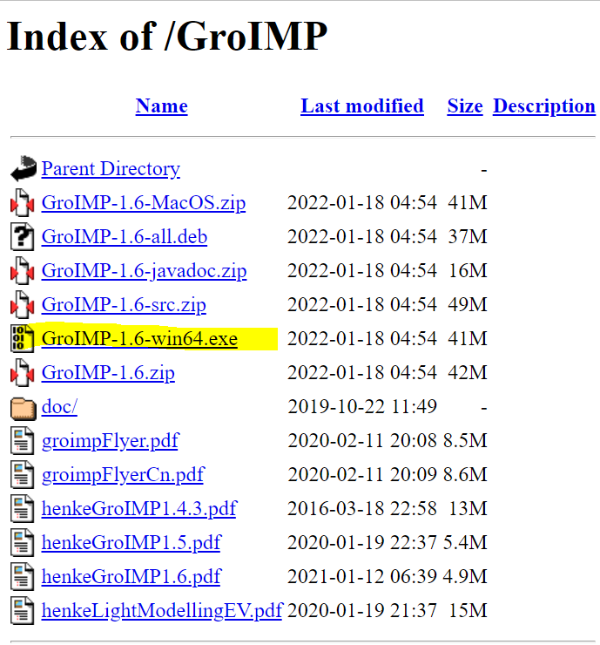

Install GroIMP 1.6 in local computer (normally in C/program files/ GroIMP 1.6). Open Windows button on desktop and research for GroIMP, then chose open file location.

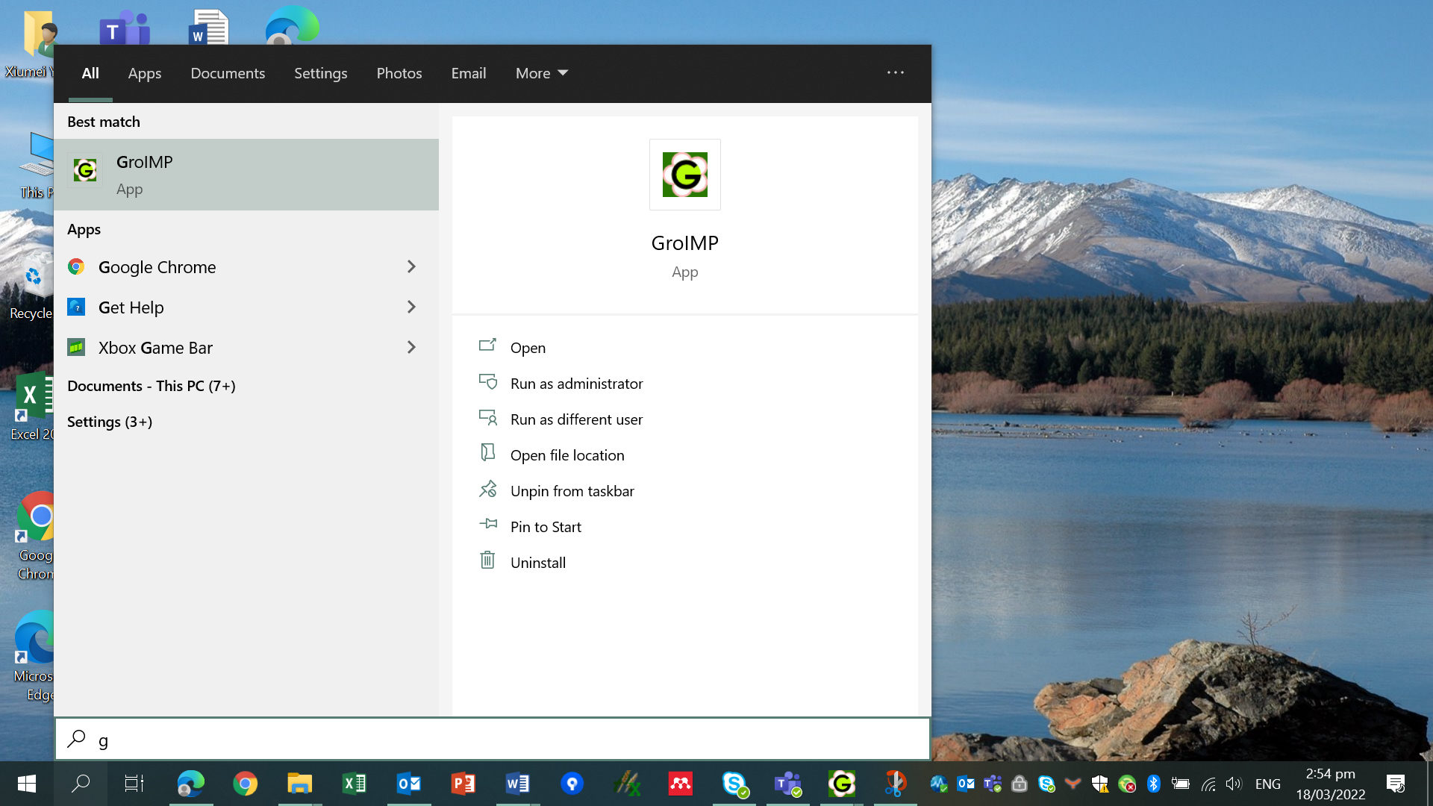

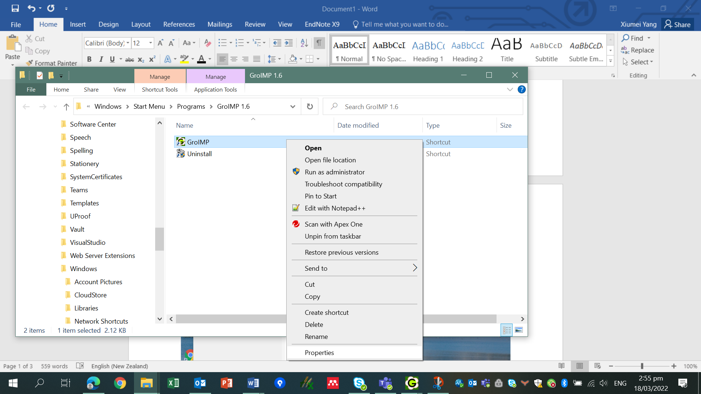

Then right click on GroIMP and chose properties. To make sure the Target is in the right location where Java is installed. For example, "C:\Program Files\Java\jre1.8.0_231\bin\javaw.exe" -Xmx8000M -jar core.jar.

Also change the number after Xmx into a bigger number (8000) to allow bigger memory space. Then click ok.

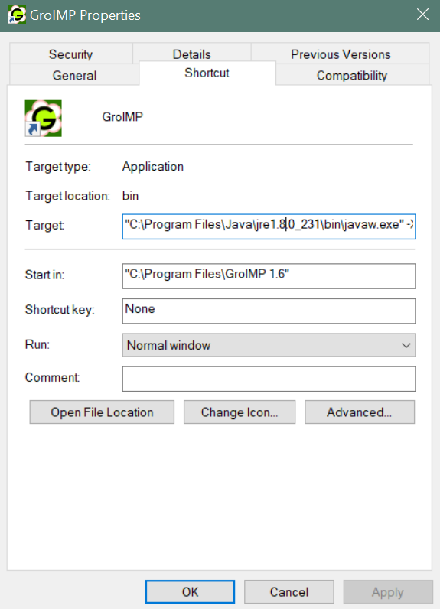

### put the ext library into the GroIMP folder where you installed it. The ext folder in the current repository is for windows platform. contact Junqi if you are using a linux system.

Copy the contents of the correponding system version into the ext folder where you installed GroIMP

Found ext file in AppleModle and copy to GroIMP installed folder (normally in C/program files/ GroIMP 1.6)

### Put the config.properties.txt in the Util folder into GroIMP folder and change the path in the txt file to where the model is located. (If you run the GroIMP, the model can create the file with a default address as well, but you still need to change the address based on your own path). If the file is missing, the model can not be opened.

Copy config.properties.txt in the Util folder from AppleModel into GroIMP folder, then change the path in the txt file to where the model is located.

### Open the GroIMP interface, and use file - open - to select the project.gs from the scripts folder to open the code.

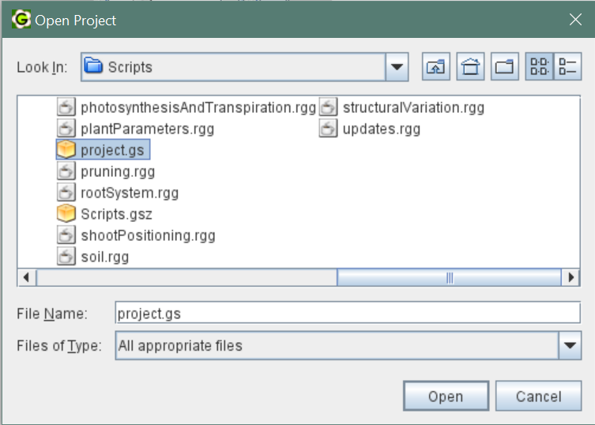

### Click save or reset to initialize it. For seeing the results of reading the digitization data, you need to further click run once.

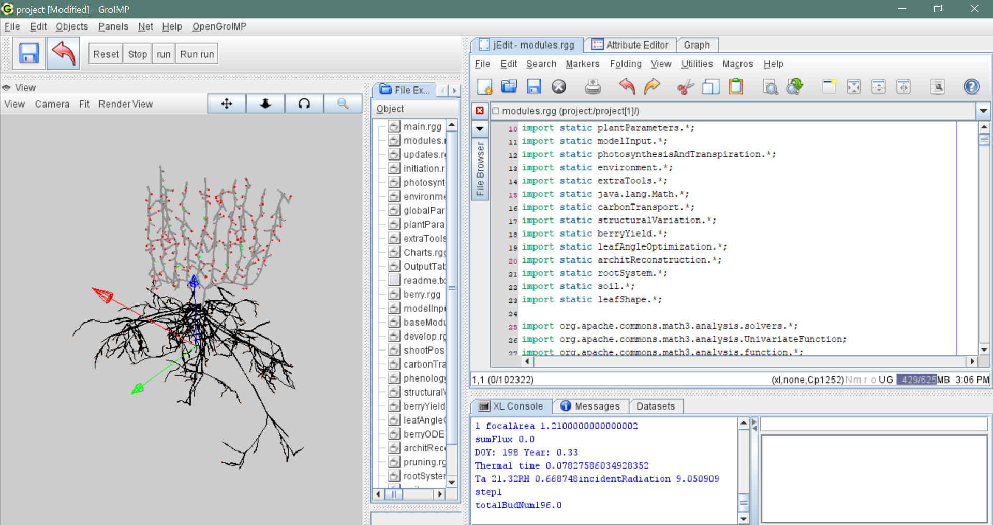

### Choose a scenario file that you are going to use in the globalParameters.rgg.

Currently not working.

### Note you can pre-explore the scenario file by a text editor to choose different functionalities, see the explaination below

#### The model has been extended to simulate different growth conditions and have variable functionalities. The model now has options to use static architecture or dynamic architecture, canopy structural variation, wire lifting, leaf angle optimization, digitized architecture or not, and simulate penology and yield or input based on observation.

#### A modularized modelling framework has been developed, where we can easily reconstruct the model structure by reading different files. For example, we can replace the initial plant structure by replacing the initiation.rgg file, and switch between using “whole-big leaf” or “leaf-facet” by replacing the leafShape.rgg file. A command pipeline has been created to facilitate the configuration of the model based on different choices.

#### scenarios can be defined in the excel file in the Scenario_file_generation/Plant_parameters/model_input_data_list_2021_4_23.xlsx

#### you can further run the Scenario_file_generation.Rmd to generate the text scenario file

#### A bash conmmand config.sh was created to updated the model code based on the boolean variables defined in the scenario file by coping correspond code from the extra module folder to the Scripts folder

#### Another bash command update.sh was created when you change the files in the Scripts folder that relates to the files in the extra module folder. So cautions needed to be paid on those files that has multible options.

#### Do not editing the organ coordinates csv file directly in excel, it causes errors of misMatch in Java. Editing them in notepad or vs code seems fine